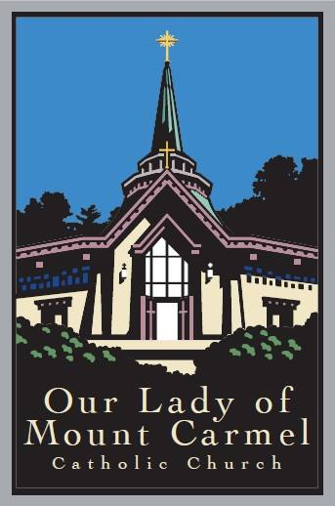
Our Lady of Mount Carmel
Director of Faith Formation

Our Lady of Mount Carmel Church, Mill Valley, California, is seeking to interview candidates for the full-time position of Director of Faith Formation.
We have begun preliminary exploration of the New Evangelization and the experience of Whole Parish Faith Formation, and we are excited and committed to implement this program in our parish. We are looking for someone to work with the pastor and music director to develop programs and processes that will deepen the faith life and commitment of our parishioners, and it is our belief that many are ready for this.

While Religious Education programs have historically focused on teaching religion to parish children, we believe it is essential to provide spiritual nourishment to parents as well, so that children have nurturing environments for their faith at home. Through the grace of their baptism, adults are, by definition, in an ongoing encounter with Jesus Christ, an encounter that is nourished through the celebration of the Eucharist and other Sacraments. A robust Faith Formation program will encourage parents to participate more frequently in the Mass and engage more fully as active members of the parish family.

The Director of Faith Formation (DFF) will collaborate with the Pastor and shall be responsible for the faith formation for children and their families in grades Kindergarten on, including sacramental preparation to be carried out according to the catechetical norms of the Archdiocese of San Francisco (including RCIC), catechist recruitment, training and support, and parent outreach. The DFF will also contribute to forming Faith Formation experiences geared to the parish at large, in which context, in collaboration with the Pastor, they will develop processes of Sacramental Preparation for Matrimony, Baptism, and RCIA.

Minimum Qualifications

Candidates wishing to apply for this position should have the following qualifications:
- practicing and active Catholic in good standing;
- BA in Theology/Religious Education or a related theological field;
- three to five years of experience working as a DFF or in parish ministry;
- proficiency in computer programs (Word, Excel, Power Point, etc),
- an understanding of and willingness to engage actively in social media.

To Apply:
Interested and qualified candidates should send a cover letter and resume to Fr. Patrick Michaels, pilgrym.ptm@gmail.com.

STATEMENT OF NON-DISCRIMINATION

All employees of the Archdiocese of San Francisco shall be employed without regard to race, color, sex, ethnic or national origin and pursuant to the San Francisco Fair Chance Ordinance, will consider for employment qualified applicants with criminal history.

